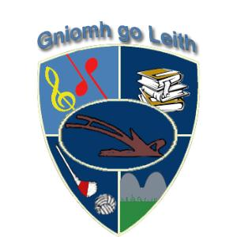

Gneeveguilla NS ANNUAL ADMISSION NOTICE
in respect of admissions to the 2024/2025 school year

Admission Policy and Application Form
A copy of the school’s Admission Policy and the Application Form for Admission for the 2024/2025 school year is available as follows: –
To download at: www.gneeveguillans.com
On request: By emailing info at gneeveguillans@gneeveguillans.com or writing to Gneeveguilla NS, Gneeveguilla, Rathmore, Co. Kerry

PART 1 - Admissions to the 2024/2025 school year

Application and Decision Dates for admission to 2023/2024 Intake
The following are the dates applicable for admission to Junior Infants:

The school will commence accepting applications on | 06/11/2023
The school shall cease accepting applications for admission on | 17/05/2024
The date by which applicants will be notified of the decision on their application is | 31/05/2024
The period within which applicants must confirm acceptance of an offer of admission is | 21/06/2024

Note: the school will consider and issue decisions on late applications in accordance with the school’s admission policy.

Number of places being made available in 2024/2025
25
The number of places being made available in junior infants is

As per Admissions Policy the BOM has deemed 25 as the number of spaces available in Junior Infants. The BOM reserves the right to change this number as necessary.

